Paper Title in APA Style Title Case
Firstname Lastname¹, Firstname Middlename Lastname², Firstname M. Lastname¹

¹Department, Institution, City, State/Province, Country
²Department, Institution, City, Country

Abstract: This document provides an example of the layout and style for the paper submissions for the Informacije MIDEM Journal. The abstract should be a total of about 200 to 250 words maximum. The abstract should be a single paragraph and should follow the style of structured abstracts, but without headings: 1) Background: Place the question addressed in a broad context and highlight the purpose of the study; 2) Methods: Describe briefly the main methods or treatments applied. 3) Results: Summarize the article's main findings; and 4) Conclusion: Indicate the main conclusions or interpretations. The abstract should be an objective representation of the article: it must not contain results which are not presented and substantiated in the main text and should not exaggerate the main conclusions.
Keywords: keyword 1; keyword 2; keyword 3; min 3 keywords; max 5 keywords
Slovene title in case of Slovene authors, or a copy of the English title
Izvleček: Slovene version of the abstract in case of Slovene authors or a copy of the English version of the abstract
Ključne besede: Slovene keywords in case of Slovene authors or a copy of English keywords

* Corresponding Author’s e-mail: email@server.com, email2@server.com

Introduction
The purpose of the introduction is to provide background and place the study in a broader context. It has to describe the purpose of the work and its importance. The current state of the art should be reviewed carefully including all the key references. Controversial or diverging hypotheses must not be ignored. A short description of the aim of the presented work and main highlights should be presented. The introduction may be concluded with the outline of the paper. Keep the introduction understandable to a wide range of readers who may not be intimately familiar with the topic of the paper.

Materials and Methods
Materials and methods should be described with sufficient detail to allow others to replicate and build on published results. New methods and protocols should be described in detail while well-established methods can be briefly described and appropriately cited. Give the name and version of any software used and make clear whether computer code used is available. Chapter name may be adapted to the topic of the manuscript or split into more chapters if it benefits the readability of the manuscript.

Preparation of papers
Authors are encouraged to use this template to prepare the manuscript for submission, but it is not mandatory. It is however mandatory to:
- Prepare the figures and tables according to these instructions
- Prepare equations according to these instructions
- Format the references according to these instructions and ensure that DOI or URL are included in the references
Additional details are available in Instructions for Authors: http://journal.midem-drustvo.si/Author.aspx

Figures and tables
Figures and tables should be numbered in the order of appearance in the paper. They should be positioned within a single column and should be up to 80 mm wide. In rare cases when a single column width is insufficient a figure or a table may span both columns and may reach up to 170 mm in width. Double column figures will be placed at the top of the page during final typesetting and double column tables at the bottom of the page, however the authors are not required to do so before the review process.
Figure captions should be placed below the corresponding figures and table captions should be placed above the tables (see Fig. 1 and Table 1). The captions are centered within a column.

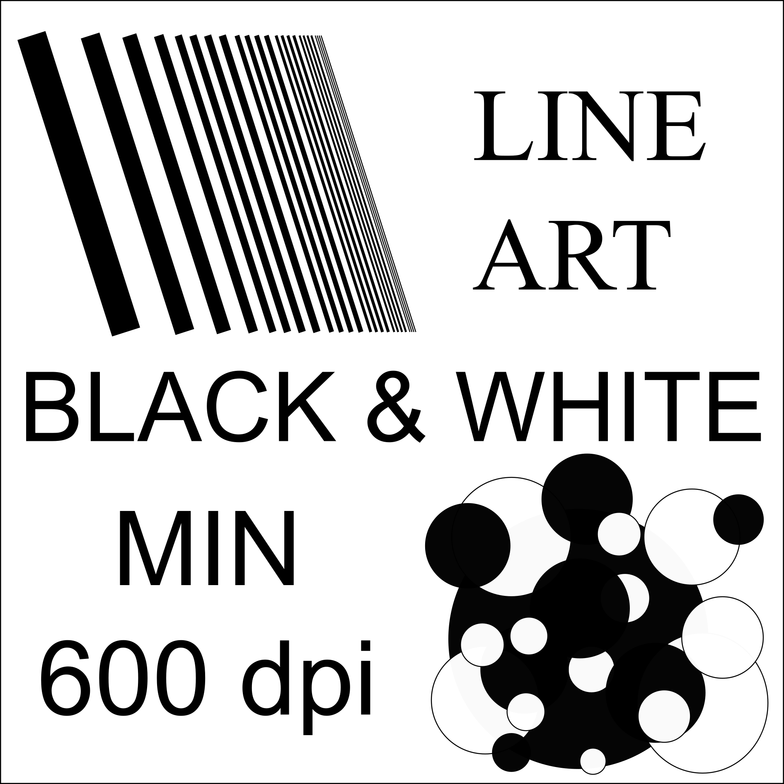
Figure 1: Black and White images must have a resolution of at least 600 dpi and a maximum width of 80 mm.
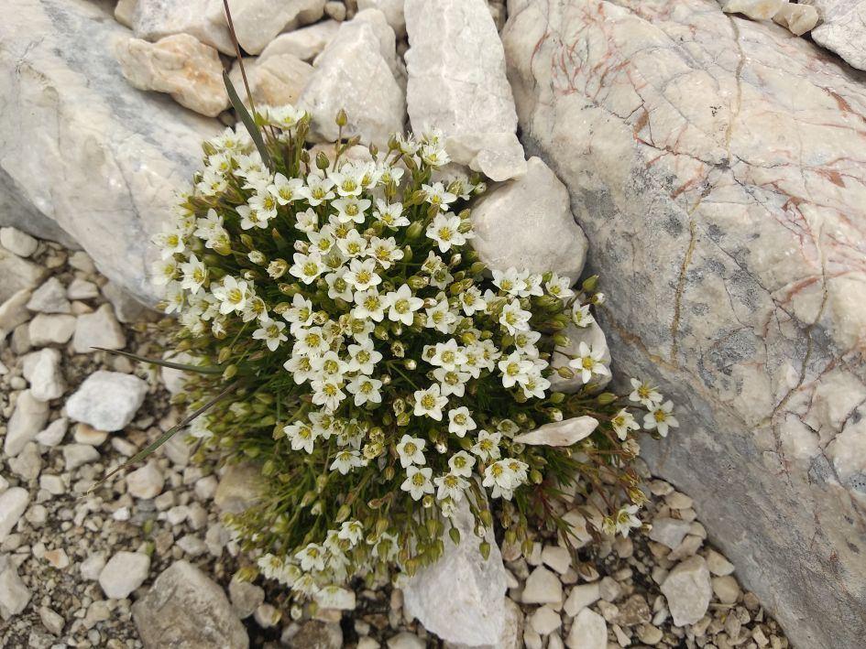
Figure 2: Grayscale and Color images must have a resolution of at least 300 dpi and a maximum width of 80 mm.
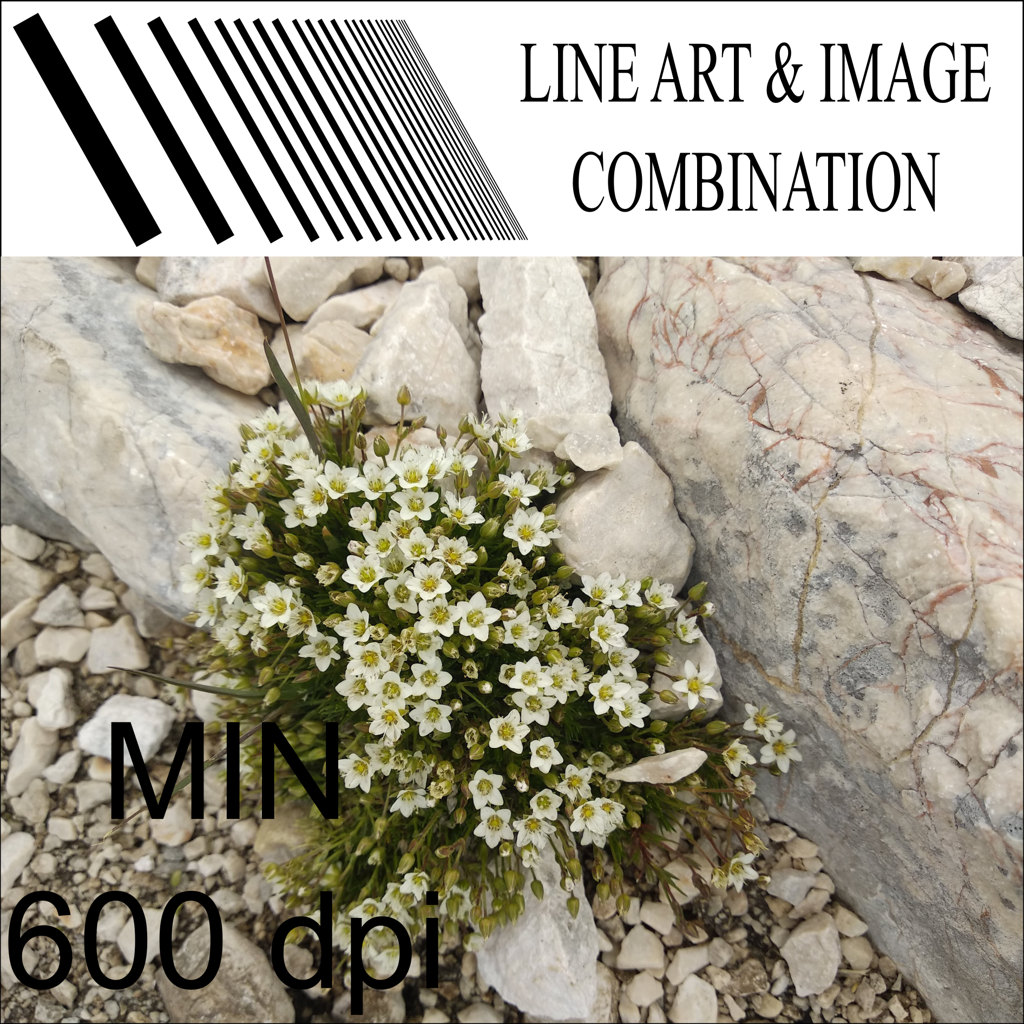
Figure 3: Images combining Black and White part and a Grayscale or Color part must have a resolution of at least 600 dpi and a maximum width of 80 mm.
Figures and tables should be placed as close as possible to the text where they are first referenced.
Table 1: Parameters and their values.
Parameter | Value
R₁ | 10 Ω
C | 15.3 µF

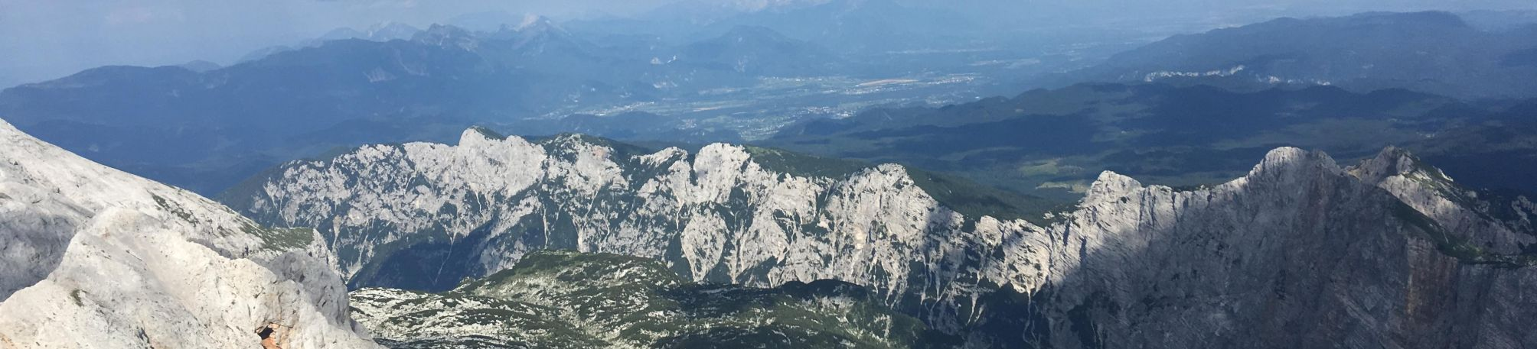
Figure 4: Double column 170 mm wide figure example.
Table 2: A wide table example. Maximum width is 170 mm.
Parameter | Value 1 | Value 1 | Value 1 | Value 1 | Value 1 | Value 1 | Value 1 | Value 1
R₁ | 10 Ω | 11 Ω | 12 Ω | 13 Ω | 14 Ω | 15 Ω | 16 Ω | 17 Ω
C | 15.3 µF | 15.3 µF | 15.3 µF | 15.3 µF | 15.3 µF | 15.3 µF | 15.3 µF | 15.3 µF

Equations
Equations should have a reference number on the right side. The reference number should be enclosed in parentheses. To reference an equation from the text, quote its reference number enclosed in brackets, e.g. see equation . Equations may be typed using the Microsoft equation editor (e.g. Eq. ($0$)) or the MathType equation editor (e.g. Eq. ).
$f\left(x,y\right)=\sum_{i=0}^{N-1}{c_{i}\left(x_{i}^{2}+y_{i}^{2}\right)}$ ($SEQ Equation \backslash * ARABIC \backslash r 0$$0$)

Symbol * does not mean multiplication, but convolution. Use either a ∙ or a × instead.
Always consider readability with regard to size of text when writing equations. While is acceptable:
The readability of Eq. would be much better if the equation was rewritten in the form

References
References must be numbered in order of appearance in the text (including table captions and figure legends) and listed individually at the end of the manuscript. We recommend preparing the references with a bibliography software package, such as Zotero, Mendeley, or EndNote to avoid typing mistakes and duplicated references. We encourage citations to data, computer code and other citable research material.
Please use “Journal of Mircoelectronics, Electronic Components and Materials” reference style available at https://csl.mendeley.com/styles/18952761/MIDEM and on the journal web page http://journal.midem-drustvo.si/Files/MIDEM.csl. The reference style is based on the IEEE reference style. The only difference is the addition of DOI or URL if doi is not available. A detailed description of the IEEE reference style is available at https://www.ieee.org/content/dam/ieee-org/ieee/web/org/conferences/style_references_manual.pdf. The most basic rules are repeated below.
In the text, reference numbers should be placed in square brackets [ ], and placed before the punctuation; for example [1], [1]–[3] or [1], [4], [5]. For embedded citations in the text with pagination, add page information within the square brackets, separated by a coma; for example [2, p. 8] or [3, pp. 70–73].
List of references should have reference numbers enclosed in square brackets aligned to the left with a hanging indent to form one column with reference numbers and one column with bodies of references. Each reference should finish with either a DOI (preferable) or URL if available.

Language
The following are English language guidelines for submissions to Informacije MIDEM :

- American English or UK English are fine as long as there is consistency.
- Please capitalize all words in the title and headings according to the APA style guide (https://blog.apastyle.org/apastyle/2012/03/how-to-capitalize-and-format-reference-titles-in-apa-style.html). Check using https://capitalizemytitle.com.
- Define abbreviations the first time they are mentioned in the abstract, text; also the first time they are mentioned in a table or figure.
- Keywords are not capitalized.
- All websites need to be referenced as does unpublished data or personal communications.
- Capitalize words such as Group, Section, Method, etc. if followed by a number, e.g. "In Group 4, five samples..."
- Dates are written out in the full, April 20, 2004 (or 20 April, 2004) rather than 20.4.04
- Write 1990s rather than with an apostrophe (1990’s) or just 90s.
- The measurement mL: the L is always a capital.
- For consistency, in table/figure headings put brackets round (A) (B) and make A and B bold.
- Write don't, can't... in full, i.e. do not, cannot
- Numbers 1 to 9 are written in full, except if part of a measurement (6–8 mL) or in the experimental/materials/methods section.
- Numbers at the beginning of a sentence should be written in full, i.e. 152 mL must be written as: One hundred and fifty two milliliters.
- There is a space after a number and before °C and units such as μL, h, min, days, but NOT before % or ° (angle).
- A sentence should not start with But or And (use however or find alternatives).
- If a reference is written at the beginning of a sentence, e.g. "[12] studied...", insert the author's name before the reference number, e.g. "Smith [12] studied" or write "The authors of [13] studied"

Cover letter
Cover letter is mandatory. The review process will not be started without it. It has to contain:
- Why the manuscript is a good candidate for this journal
- List of potential reviewers
- Declaration that the manuscript has not been published or is under consideration for publication elsewhere
More detailed instructions are available in Instructions for Authors.

Results
Provide a concise and precise description of the experimental results, their interpretation as well as the experimental conclusions that can be drawn.

Discussion
Authors should discuss the results and how they can be interpreted in perspective of previous studies and of the working hypotheses. The findings and their implications should be discussed in the broadest context possible and limitations of the work highlighted. Future research directions may also be mentioned. This section may be combined with Results.

Conclusions
The conclusions should summarize the main findings and achievements of the presented work. Please check these instructions for possible updates before submitting the final paper.

Supplementary material
Supplementary material available on the publishers web page contains:
- Measurement data shown in Figs 3, 5, and 6.
- A video demonstration of the experiment.
- Source code for the microprocessor on module A.

Acknowledgments
Acknowledgments (if any) should appear as a separate section before the list of references.

Conflict of Interest
Put your Conflict of Interest statement here.
Put your statement about the role of the funding sponsors here.
Put your declaration of conformance to the Declaration of Helsinki of 1975 if the research involved human subjects, materials, tissues, or human data. Remove otherwise.
Review process will not be started unless all the required statements are provided! Check instructions for authors for details!

References
[1] J. K. Author, “Name of the Paper,” Abbrev. Title Period., vol. 25, no. 3, pp. 99–108, 2020, https://doi.org/10.33180/InfMIDEM2019.xyz.
[2] J. K. Author, Book Title, 1st ed. London, 2018.
[3] J. K. Author, “Chapter Title,” in Book Title, 1st ed., J. N. Editor, Ed. New York: Publishe rName, 2016, pp. 66–88, https://free.book.org/book.html.
[4] U. Authors, “Web Page Title.” [Online]. Available: https://www.google.com. [Accessed: 01-Jan-2020].
[5] J. K. Author, “Conference Paper Title,” in 15th ABC Conference Proceedings, 2015, pp. 236–241, https://doi.org/12.34567/lalala.xyz.

Copyright © 20xx by the Authors. This is an open access article distributed under the Creative Commons Attribution (CC BY) License (https://creativecommons.org/licenses/by/4.0/), which permits unrestricted use, distribution, and reproduction in any medium, provided the original work is properly cited.
Arrived: xx.xx.xxxx
Accepted: xx.xx.xxxx

